**Name:** Mostafa Mohamed Mohamed Aboarab

**B.N:** 930

**Date:** 28-5-2020

**Topic:** Operating system

# Application brief:

An operating system, or "OS," is software that communicates with the hardware and allows other programs to run. It is comprised of system software, or the fundamental files your computer needs to boot up and function. Every desktop computer, tablet, and smartphone include an operating system that provides basic functionality for the device.

* Examples of Operating Systems

Laptops, tablets, and desktop computers all run operating systems that you've probably heard of. Some examples include versions of Microsoft Windows (like [Windows 10](https://www.lifewire.com/windows-10-2626217), [Windows 8](https://www.lifewire.com/windows-8-2626235), [Windows 7](https://www.lifewire.com/windows-7-2626265), [Windows Vista](https://www.lifewire.com/windows-vista-2626311), and [Windows XP](https://www.lifewire.com/windows-xp-2626354)), [Apple's macOS](https://www.lifewire.com/what-is-macos-4691239) (formerly OS X), [Chrome OS](https://www.lifewire.com/google-chrome-os-1616448), BlackBerry Tablet OS, and [flavors of Linux,](https://www.lifewire.com/unix-flavors-list-4094248) an open source operating system. Screenshots: Your smartphone runs a [mobile operating system](https://www.lifewire.com/what-is-a-mobile-operating-system-2373340), probably either [Apple's iOS](https://www.lifewire.com/what-is-ios-1994355) or [Google's Android](https://www.lifewire.com/what-is-google-android-1616887). Both are household names but you may not have realized

that they are the operating systems running on those devices. [Servers](https://www.lifewire.com/servers-in-computer-networking-817380), like those that host the websites you visit or serve the videos you watch, typically run specialized operating systems, designed and optimized to run the special software required to make them do what they do. Some examples include Windows Server, Linux, and FreeBSD.

# Screenshots:

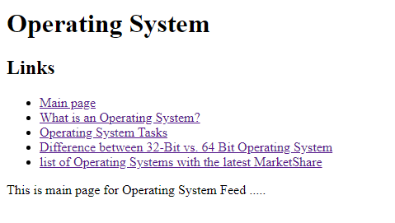

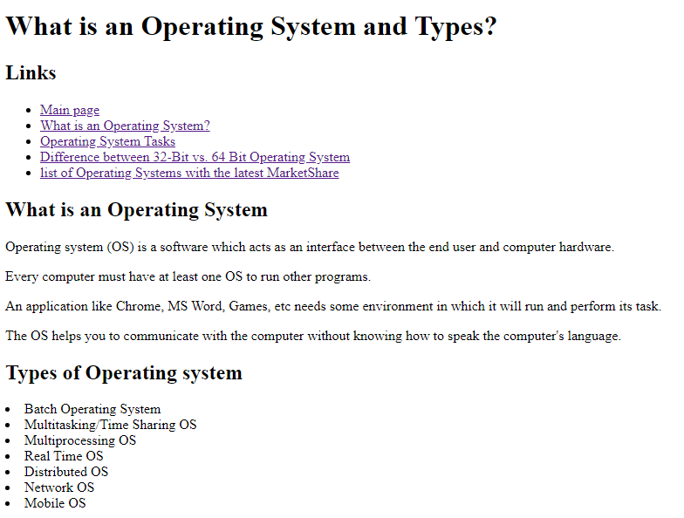

# 

# 

# Source code:

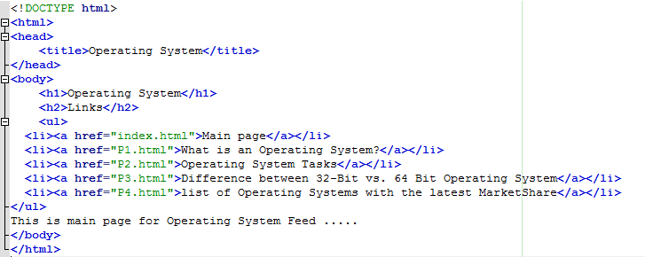

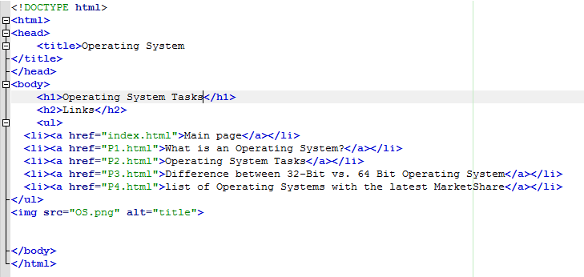

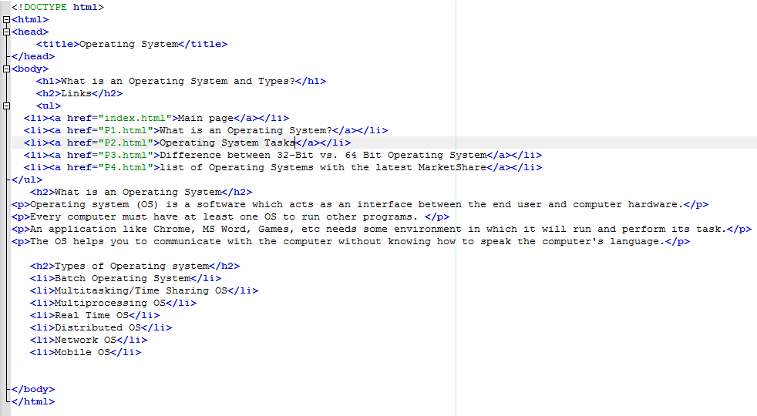

Reference

* <https://www.guru99.com/operating-system-tutorial.html>
* <https://hexacit.com/en/blog/3/Types-and-functions-of-operating-systems>
* <https://www.lifewire.com/operating-systems-2625912>